Aim: TextRank for Document Summarization
IDE: Google Colab

Theory:
TextRank is an algorithm based on PageRank, which often used in keyword extraction and text summarization. In this article, I will help you understand how TextRank works with a keyword extraction example and show the implementation by Python.
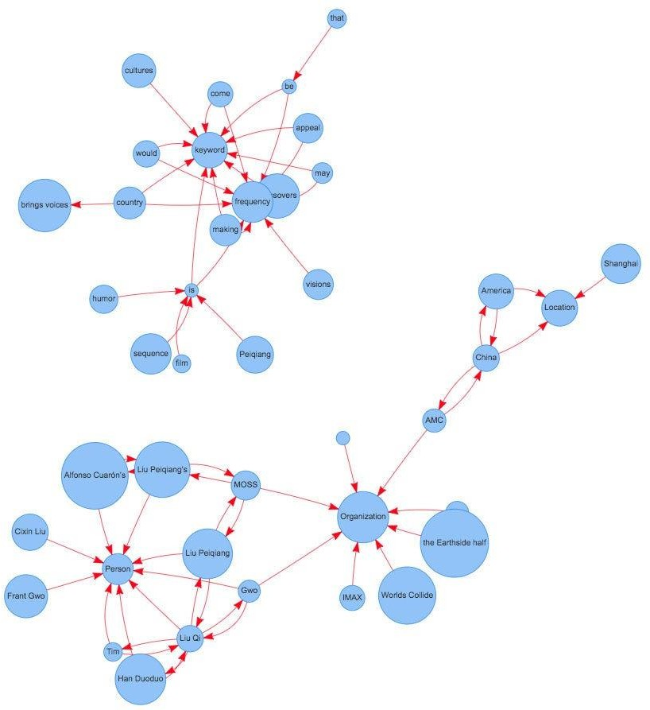

Understand PageRank

There are tons of articles talking about PageRank, so I just give a brief introduction to PageRank. This will help us understand TextRank later because it is based on PageRank. PageRank (PR) is an algorithm used to calculate the weight for web pages. We can take all web pages as a big directed graph. In this graph, a node is a webpage. If webpage A has the link to web page B, it can be represented as a directed edge from A to B. After we construct the whole graph, we can assign weights for web pages by the following formula.

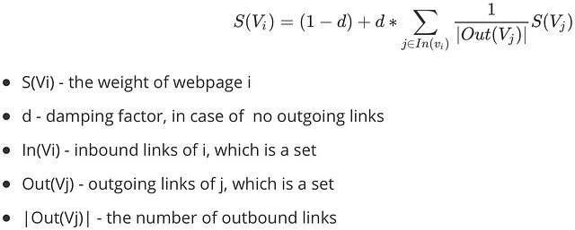
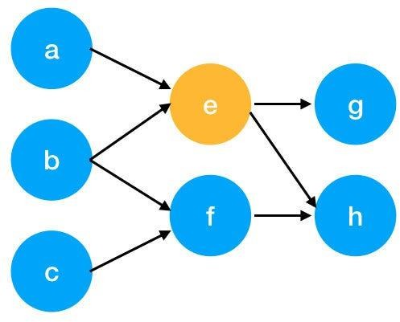

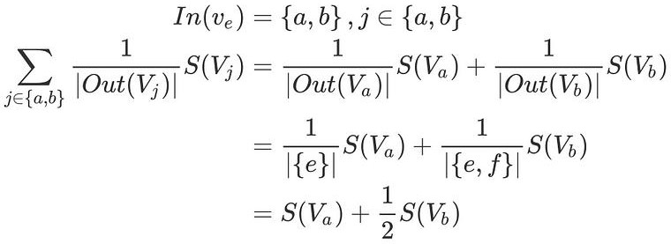
Here is an example to better understand the notation above. We have a graph to represent how web pages link to each other. Each node represents a webpage, and the arrows represent edges. We want to get the weight of webpage e. We can rewrite the summation part in the above function to a simpler version.
We can get the weight of webpage e by the following function.

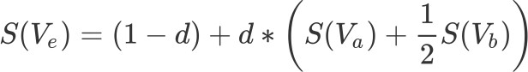

We can see the weight of the webpage e is dependent on the weights of its inbound pages. We need to run this iteration much time to get the final weight. In the initialization, the importance of each webpage is 1.

TextRank for document Summarization
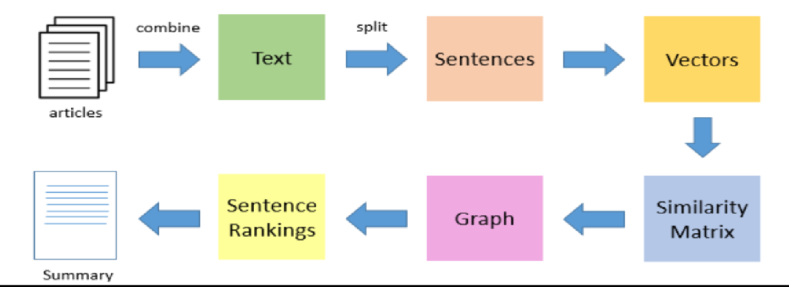

TextRank works in the following steps:
- Tokenize documents into sentences.
- Preprocess each sentence in the document.
- Count key phrases and normalize them or produce TFIDF Matrix, you can also use any kind of vectorization such as spacy vectors.
- Calculate the Jaccard Similarity between sentences and key phrases.
- Rank the sentences with higher significance.

Pre Lab Exercise:

1. How keyword extraction is similar to document summarization process?

Keyword extraction and document summarization are similar because both aim to identify the most important information from a text. They reduce the size of the original content while preserving its main meaning. Both methods analyze word frequency, importance, and relationships between words or sentences to determine which parts of the text are most relevant.

2. How keyword extraction is different to document summarization process?

Keyword extraction focuses on selecting important words or phrases that represent the main topics of the text, while document summarization selects important sentences to create a shorter version of the original document. Keywords provide a quick idea about the topic, whereas summarization provides a brief explanation of the content.

3. Limitation of TextRank as a summarizer

TextRank has some limitations because it mainly depends on word or sentence similarity and does not fully understand the meaning of the text. It may ignore context, produce summaries that are not very coherent, and sometimes include repetitive or less important sentences. It also does not handle very complex language structures effectively.

Program (Code):
# Textrank for document summarization
#importing basic libraries

import numpy as np
import nltk
import networkx as nx
from nltk.tokenize import sent_tokenize, word_tokenize
from nltk.corpus import stopwords
from sklearn.metrics.pairwise import cosine_similarity
from collections import Counter
#download nltk resources
nltk.download('punkt')
nltk.download('stopwords')
def preprocess_text(text):
stop_words=set(stopwords.words('english'))
sentences=sent_tokenize(text)
word_frequencies=[]

for sent in sentences:
word=word_tokenize(sent.lower())
filtered_words=[w for w in word if w.isalnum() and w not in stop_words]
word.frequencies=Counter(filtered_words)
return sentences, word_frequencies
def similarity_matrix(word_frequencies):
size=len(word_frequencies)
sm=np.zeros((size,size))
for i in range(size):
for j in range(size):
if i!=j:
words1=word_frequencies[i]
words2=word_frequencies[j]
common_words=set(words1.keys()).union (set(words2.keys()))

vec1=np.array([words1[word] for word in common_words])
vec2=np.array([words2[word] for word in common_words])

sm[i][j]=cosine_similarity([vec1],[vec2])[0,0]
return sm
def textrank(text,num=3):
sentences,word_frequencies=preprocess_text(text)
sm=similarity_matrix(word_frequencies)

#build graph and apply pagerank
graph=nx.from_numpy_array(sm)
scores=nx.pagerank(graph)

ranked_sentences=sorted(((scores.get(i,0),s)
for i,s in enumerate(sentences)),reverse=True)
summary=" ".join(sent for _,sent in ranked_sentences[:num])
return summary
text="""
India, officially the Republic of India,[j][20] is a country in South Asia. It is the seventh-largest country by area; the most populous country since 2023;[21] and, since its independence in 1947, the world's most populous democracy.[22][23][24] Bounded by the Indian Ocean on the south, the Arabian Sea on the southwest, and the Bay of Bengal on the southeast, it shares land borders with Pakistan to the west;[k] China, Nepal, and Bhutan to the north; and Bangladesh and Myanmar to the east. In the Indian Ocean, India is near Sri Lanka and the Maldives; its Andaman and Nicobar Islands share a maritime border with Myanmar, Thailand, and Indonesia.

Modern humans arrived on the Indian subcontinent from Africa no later than 55,000 years ago.[26][27][28] Their long occupation, predominantly in isolation as hunter-gatherers, has made the region highly diverse.[29] Settled life emerged on the subcontinent in the western margins of the Indus river basin 9,000 years ago, evolving gradually into the Indus Valley Civilisation of the third millennium BCE.[30] By 1200 BCE, an archaic form of Sanskrit, an Indo-European language, had diffused into India from the northwest.[31][32] Its hymns recorded the early dawnings of Hinduism in India.[33] India's pre-existing Dravidian languages were supplanted in the northern regions.[34] By 400 BCE, caste had emerged within Hinduism,[35] and Buddhism and Jainism had arisen, proclaiming social orders unlinked to heredity.[36] Early political consolidations gave rise to the loose-knit Maurya and Gupta Empires.[37] This era was noted for creativity in art, architecture, and writing,[38] but the status of women declined,[39] and untouchability became an organised belief.[l][40] In South India, the Middle kingdoms exported Dravidian language scripts and religious cultures to the kingdoms of Southeast Asia.[41]

In the 1st millennium, Islam, Christianity, Judaism, and Zoroastrianism became established on India's southern and western coasts.[42] In the early centuries of the 2nd millennium Muslim armies from Central Asia intermittently overran India's northern plains.[43] The resulting Delhi Sultanate drew northern India into the cosmopolitan networks of medieval Islam.[44] In south India, the Vijayanagara Empire created a long-lasting composite Hindu culture.[45] In the Punjab, Sikhism emerged, rejecting institutionalised religion.[46] The Mughal Empire ushered in two centuries of economic expansion and relative peace,[47] and left a rich architectural legacy.[48][49] Gradually expanding rule of the British East India Company turned India into a colonial economy but consolidated its sovereignty.[50] British Crown rule began in 1858. The rights promised to Indians were granted slowly,[51][52] but technological changes were introduced, and modern ideas of education and the public life took root.[53] A nationalist movement emerged in India, the first in the non-European British Empire and an influence on other nationalist movements.[54][55] Noted for nonviolent resistance after 1920,[56] it became the primary factor in ending British rule.[57] In 1947, the British Indian Empire was partitioned into two independent dominions, a Hindu-majority dominion of India and a Muslim-majority dominion of Pakistan. A large-scale loss of life and an unprecedented migration accompanied the partition.[58]

India has been a federal republic since 1950, governed through a democratic parliamentary system. It is a pluralistic, multilingual and multi-ethnic society. India's population grew from 361 million in 1951 to over 1.4 billion in 2023.[59] During this time, its nominal per capita income increased from US$64 annually to US$2,601, and its literacy rate from 16.6% to 74%. A comparatively destitute country in 1951,[60] India has become a fast-growing major economy and a hub for information technology services, with an expanding middle class.[61] India has reduced its poverty rate, though at the cost of increasing economic inequality.[62] It is a nuclear-weapon state that ranks high in military expenditure. It has disputes over Kashmir with its neighbours, Pakistan and China, unresolved since the mid-20th century.[63] Among the socio-economic challenges India faces are gender inequality, child malnutrition,[64] and rising levels of air pollution.[65] India's land is megadiverse with four biodiversity hotspots. India's wildlife, which has traditionally been viewed with tolerance in its culture,[66] is supported in protected habitats.
"""
[nltk_data] Downloading package punkt_tab to /root/nltk_data...
[nltk_data] Package punkt_tab is already up-to-date!
True
print(textrank(text, num=5))

Results:
[l][40] In South India, the Middle kingdoms exported Dravidian language scripts and religious cultures to the kingdoms of Southeast Asia. [65] India's land is megadiverse with four biodiversity hotspots. [63] Among the socio-economic challenges India faces are gender inequality, child malnutrition,[64] and rising levels of air pollution. [62] It is a nuclear-weapon state that ranks high in military expenditure. [61] India has reduced its poverty rate, though at the cost of increasing economic inequality.

Observation:

In this experiment, TextRank was used for keyword extraction and document summarization. It identifies the most important words and sentences by analyzing relationships between them. The method is simple, efficient, and does not require training data. However, TextRank may not fully understand context and can sometimes produce less coherent summaries. Overall, it is an effective technique for extracting important information from text.

Post Lab Exercise:
- Write about “your ownself” (in not more than 500 words→ You know better about you, rather than ChatGPT!!). Generate the summary of your portfolio in
  - 50% of the size of your portfolio
  - 25% of the size of your portfolio

Comment over the summary obtained. Which sentence you think should be there in your summary, but was not spotted by textrank? Rate the overall summary in the scale of 1-5 (with 1 as least and 5 as highest rating). Paste the code, your portfolio, output and your analysis.
Code:
!pip install sumy
import nltk
nltk.download('punkt')
nltk.download('punkt_tab')
portfolio_text = """
I am a motivated and curious Information and Communication Technology student who enjoys learning how technology can be used to solve real-world problems.
I have worked on projects that combine software and hardware, which helped me develop problem-solving skills and technical confidence.
One of my early projects was an RFID-based barrier system that allows access only to authorized users.
This project helped me understand sensors, identification systems, and system design.

I have also worked on smart technology-based solutions such as an IoT-based safety system and a smart elevator system that uses sensors and machine learning to improve efficiency and safety.
Through these projects, I have learned Python programming, basic machine learning concepts, and microcontroller interfacing.
I am also familiar with web technologies such as HTML, CSS, JavaScript, jQuery, and PHP, which help in designing user-friendly interfaces.

Apart from technical skills, I am a disciplined and focused individual who believes in continuous improvement.
I am currently preparing for placements to strengthen my core knowledge in digital electronics, communication systems, and probability.

I enjoy working in teams and collaborating with others because teamwork often leads to better ideas and innovative solutions.
My goal is to develop technologies that make systems smarter, safer, and more efficient.
"""
from sumy.parsers.plaintext import PlaintextParser
from sumy.nlp.tokenizers import Tokenizer
from sumy.summarizers.text_rank import TextRankSummarizer

# Parse text
parser = PlaintextParser.from_string(portfolio_text, Tokenizer("english"))

# Create summarizer
summarizer = TextRankSummarizer()

# Count sentences in original text
total_sentences = len(list(parser.document.sentences))

# 50% summary
summary_50 = summarizer(parser.document, int(total_sentences * 0.5))

# 25% summary
summary_25 = summarizer(parser.document, int(total_sentences * 0.25))

# Print results
print("ORIGINAL SENTENCES:", total_sentences)

print("\n50% SUMMARY:\n")
for sentence in summary_50:
print(sentence)

print("\n25% SUMMARY:\n")
for sentence in summary_25:
print(sentence)

Result:
ORIGINAL SENTENCES: 11

50% SUMMARY:

I am a motivated and curious Information and Communication Technology student who enjoys learning how technology can be used to solve real-world problems.
I have worked on projects that combine software and hardware, which helped me develop problem-solving skills and technical confidence.
I have also worked on smart technology-based solutions such as an IoT-based safety system and a smart elevator system that uses sensors and machine learning to improve efficiency and safety.
I am currently preparing for placements to strengthen my core knowledge in digital electronics, communication systems, and probability.
I enjoy working in teams and collaborating with others because teamwork often leads to better ideas and innovative solutions.

25% SUMMARY:

I am a motivated and curious Information and Communication Technology student who enjoys learning how technology can be used to solve real-world problems.
I have also worked on smart technology-based solutions such as an IoT-based safety system and a smart elevator system that uses sensors and machine learning to improve efficiency and safety.

